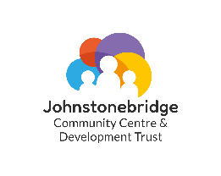

Minnygap Community Fund Award 2026

Individuals from Johnstonebridge may apply for a grant of up to £300, constituted groups can apply for up to £600 towards projects that meet at least one of the following purposes:

- enhance the quality of life and promote people’s well-being
- promote community spirit and bring people together
- foster vibrant, sustainable communities.

Contact Details

Name of group or individual applying:

Main contact:

Address:

E-mail:

About you and/or your organisation
Please make sure all members of the group are aware of and agree with the application

Where does your group meet?

Are you a constituted group?
If you are not a constituted group please explain who is involved in the group and what has brought you together.

Details of the grant request

How much are you requesting? £

Please provide details of your project –
1. What activities will you carry out? / 2. Who are the beneficiaries? / 3. Do the members or attendees pay a fee and what does this pay for?

What will the grant be used to pay for (please list items)?

If you are a not a constituted group please indicate the sponsoring organisation that will receive the grant on your behalf and account for it in due course. This may be the Community Centre.

Name of organisation:

Declaration: I certify that the information contained in this application is correct and that I am authorised to make the application on behalf of the above group/individual.

Name (please print):

Signature: Date:

Declaration from sponsoring organisation where the application is from a non-constituted group: I certify that we are supporting this group to undertake this project by administering the grant on their behalf.

Name (please print):

Signature: Date:

Please email your completed application to Helen Thornton at the Centre or by email to admin@johnstonebridgecentretrust.co.uk

All receipts must be kept, and all grant expenditures must be noted for our records. You will be asked to fill out a short form once funds are spent, this is just for the Trust and our fund providers to ensure all funds are distributed correctly.

Applications will be emailed out to the Board for review, we hope to respond to all applicants within a week.

