JBCCT Board Meeting
Tuesday 14th January 2024 at 7.30pm
At the Johnstonebridge Centre
Members Present:
John Graham
George Muirhead
Billy Lockhart
Shelby Watson
David Johnson
Kirsty Sloan

In attendance:
Helen Thornton (Admin)

Minutes:
1 | Welcome and Apologies  David welcomed everybody to the meeting. Apologies- Julia Barnard, Wendy Telford & Kevin Bennison. | Action
2 | Minutes of the Previous Meeting  The previous minutes of 02nd of October were proposed by George Muirhead, and Seconded by Billy Lockart.
3 | Rural housing update  Wheatley Homes had a short interview with the community centre to ask how we feel the new builds will positively impacting the community, this is on their website.  The roads department has sent over the school's street names to be proposed. See attached. Any comments or additions can be made. The board liked the street names Forest Terrace & Willow Place but were unsure about Lovewood Meadows. It was proposed to talk to the villagers who live opposite the site to ask their opinions and discuss ideas. | HT
4 | Treasurers Report  No comments on the finance document. Helen and Sue are working on the end of year 2023-4 | HT/SR
5 | Report on Centre Activity  Calander was viewed for activities. It was noted that we had fewer birthday parties booked than in previous years. It was recommended that we advertise to show that the hall can be hired at weekends.  The Pumpkin Festival went extremely well with over 40 attending £189 was taken in ticket sales. Special thank you to Kirsty for helping organise the event, and also to George and John of course.  50s night was not so well attended which was a shame.  Pilates has started at the centre on Monday mornings and now an extra class on Thursdays.  The BBC came to the centre on the 14th they got great coverage of the school children. The village turnout was fantastic with people at the hall and others along the cycle route.  1st December was the light switch on 3pm – 4.30pm ,first hour in the hall with music & hot choc then short walk with lanterns around the hall as the weather was bad, £ 119.36 taken in donations and raffle money.  Burns night has been planned and will run if over 15 tickets are sold by the 18th . Event to be held on the 25th with bar. Billy will help try and locate a piper. | HT  BL
6 | Funding  We were not able to get on the council list for light installation for the village, so funding was needed to cover costs, we have managed to match fund Micro grant , a council donation and Minnigap to cover costs.  Both our applications for ANCBC & MINNYGAP for the solar panels and battery storage are still awaiting the panel meeting decision.  The large grant application for some of the centre running costs (£10,429.31) has been approved.  The large grant application for fencing the rear of the building for safety reasons (£1524) has been approved. Samson Fencing have been contacted for a start date.  Funds for the bouncy castle/fan/insurance cover for 1 year– £ 2258.75 has been returned to Foundation Scotland as discussed last meeting.  New applications to review – Shonaigh Henderson / Craft & Chat / Yarn Bomber  The remaining Trust Micro grant funds before these applications are £619.15.  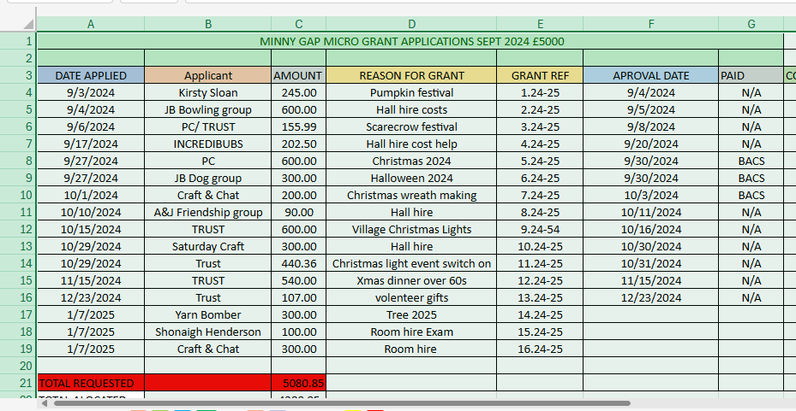  The main groups funding spends since Micro grants starting 2022 both Clyde and Minnygap.  Dog group -£1595 / Toddler group - £1290 / Parent council – £2454  Craft and chat- £1970 / Saturday craft - £690 / Trust – £4244.36 /  Bowling £1830  The Trust approved the Grants for Yarn Bomber and also Craft and Chat. The grant for Shonaigh Henderson was thought to be better applying under the Minnygap Education and Training fund in the first instance.  As the community funds are almost spent David commented that we should ask for the top up and also send over the document to show how the funds have been spent | HT
7 | Current business  - Field drainage- Helen George and John to pick up lime asap.  - Village Car Park –– Wheatly homes were asked at lunch club to have a look at the area, they came back to say they feel something could be done, we are leaving it with them but will check on any progress.  - Foundation Scotland - endowment fund. David is making progress.  D) Crazy golf – No further steps have been made on this project as yet. It was agreed to take this of the minutes for next meeting as the project needs some time dedicating to it.  - Post office heating – Kevin, All Spark has quoted £774.00+vat to replace the old wall heater. This is the top-of-the-range Rontie heater and a cheaper quote can be obtained if necessary, if we are happy to proceed how should we fund the project? The board discussed how once the solar panel and battery store are in place it might not be such an issue and to wait until the panels are in place before taking any action.  - Self-build plot – Helen has now sent on plans to the prospective buyer. We are waiting on a response to see if the plot is of interest before taking further steps. Helen to make contact one more time as there has been no response.  - Timber Cladding – David spoke with Robbie Lockhart and is happy with the paint finish on the timber, The board looked at colour options and green was the most popular choice. Helen to see if there are any alternative shades in the range and book Robbie for his next available time slot.  H) Bus stops – We also asked the council if cleaning the bus stops could be added to their street clean list, earlier this month a new bus stop appeared, so no cleaning is necessary.  I)Play park – The park has had its annual report with some comments needing attention we intend on sending this to Wicksteed’s to see if some parts can be replaced under warranty, however, none of the park has been condemned so are unsure if we can get anything replaced. Helen to contact Wicksteed . | HT/GM  LDJ  HT  HT  HT  HT
8 | AOB  1.Phone - We pay £30 a month for the landline, and might be able to make a saving if we use the centre mobile as our main number. If there is not any cost saving we can simply divert the centre number to the mobile as the centre phone's battery no long holds it charge for long. This was agreed  2. Toddler group – Toddler group has had low numbers for a few sessions now ,funds and funding are all used after the 16th January. It was agreed to have a break until Eater before starting the group up again. It was also discussed that it might be more cost effective to have the group once a month.  3. Passing place – Kirsty mentioned that a few complaints had come in about the mud on the road from tractors , a way around this would be to include passing places. Kirsty will investigate further.  4. Village fence repair – In the high winds a fence belonging to the Trust came down, it is not causing an obstruction but needs repair, It was suggested that Russ could repair the fence and the Board agreed.  5. Money transfer - £15000 was agreed to be transferred into the revenue account from the capital as funds are low and it is mainly grant money in the account. This was agreed.  6. Safe – The bar float £158 had gone missing from the safe, it was believed to have gone during the Halloween event in October. The safe had been left open while change was being given out, the missing money was not noticed until bank reconciliation was being completed. The money has been replaced with funds taken from catering events held at the centre. The board agreed it was a sad thing to have happened but lessons to be learned, bar float to be left in the cash tin in the safe in future, also the storeroom door to be locked and extra care taken when helping people with change.  7. Johnstone Mill – Billy has a contact who's father was a big part of the old mill , He has the original mill stone and photos. He would like to pass them on to a community group / Trust if they felt it was of interest. The board agreed this would be of great interest. | HT  KS  HT  HT/SR  BL
 | Date of Next meeting: 11th March 7.30PM

