JBCCT Board Meeting
Wednesday 02nd October 2024 at 7.30pm
At the Johnstonebridge Centre
Members Present:
Julia Barnard
John Graham
George Muirhead
Billy Lockhart
Wendy Telford
Kevin Bennison

In attendance:
Helen Thornton (Admin)
Katie Nairn
John Hue

Minutes:
1 | Welcome and Apologies  Julia welcomed everybody to the meeting. Apologies-, Shelby Watson , Kirsty Sloan, David Johnstone. | Action
2 | Minutes of the Previous Meeting  The previous minutes of 07th of August were proposed by George Muirhead, and Seconded by Julia Bernard.
3 | Rural housing update  Julie from Wheatly homes-  Wheatly Homes are due to visit the lunch club on the 9th Oct along with some school children to talk about St names.
4 | Treasurers Report  Helen and Sue going over last year’s accounts. No comments on the finance document. | HT/SR
5 | Report on Centre Activity  Summer Funday was a hit, with live music, a bouncy castle and ice cream. Around 40 attended Total raised (tombola/ food/stalls/tea and coffee)£225.76  The Centenary Johnstonebridge village show was also very well attended.  Coming up in October we have the ‘ladies’ 80’s night ‘ (12th), ‘Six five Special’ (19th) 50’s music night (externally booked) and Johnstonebridge Pumpkin Festival. (20th)  Zumba now takes place on a Wednesday evening and Incredibubs (baby massage and dance) are booked with us on a regular Friday morning.
6 | Funding  Both our applications for ANCBC & MINNYGAP for the solar panels and battery storage have been waiting on the outcome of the external independent advice with Business Energy Scotland, the results came back with an agreement that our project will help both us and the environment, the grant funders meet in October and will discuss the outcome, Ross has been asked to re-quote as it has been some time since the start of the project.  Last meeting we had been awarded £ 2258.75 for the bouncy castle/fan / insurance cover for 1 year– Since the award, the logistics and time to set up and break down have been re-assessed, and the volunteers feel it would be too much to take on before and after parties. – It was agreed that Helen should contact Foundation Scotland to send back the funds.  We applied for a grant with Minny gap to cover hall hire fees for ‘Baby and toddler group’, to continue this was approved and the group has funding up until December 2024.  We have now placed a large grant application for some of the centre running costs (£10,429.31) funding panel meeting 6/01/25.  We have placed a large grant application for fencing the rear of the building for safety reasons (£1524) funding panel meeting 6/01/25  The Trust have received £5000 from Foundation Scotland as a micro-grant to be used for group’s and individuals from the parish. Below shows use of funds so far.  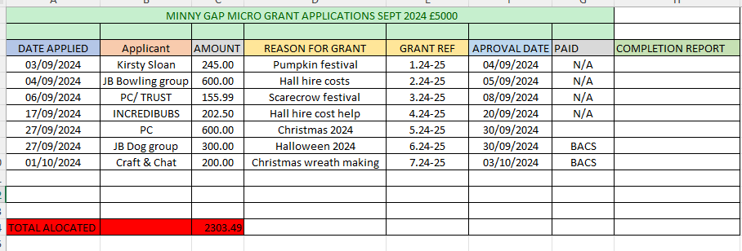  At the next board meeting the board requested a summary of individual group grants given over the micro-grant scheme. | HT  HT
7 | Current business  A) Field drainage- The ground is naturally draining as it does every year, Helen , George and John to collect lime ASAP.  B) POD’S for the village – Johns Hue , owner of Wig Wam in Moffat came along to discuss his experiences with owning ‘Glamping Pods’. His advice was that they are an expensive outlay with not a great deal of return with out full dedication, they have 6 pods in total the cleaning and upkeep is constant. Since the rise of building materials, he doesn’t feel that it is a viable project. He recommended that looking at campervan / motorhome electrical hook up could be the way to go. The board thanked John for coming along. The board went onto discuss the project and it was agreed to drop the project as cost and upkeep would be too demanding.  C) Village gravel path – The village path has been completed, huge thank you to George , John, Stuart, Greg and Slavko.  E) Village car Park and fence – Helen spoke with Steven Thompson , he agreed a waste piece of land would suit being a parking area and would make enquires, Wheatly homes (who own the land ) are due in to see Lunch club and the school on Wednesday the 9th October , Helen is to ask if any provisions could be made by them to make the space more accessible for cars especially with the increase of demand the school may face once the new housing is complete in the centre of the village.  F) Community project officer – Helen emailed Templand and Beattock about our decision on the project from last meeting  I am getting in touch to follow up on the Community Project officer role.  At the last Board meeting thoughts were that the amount of funding needed would affect the long-term funds.  We spoke to Foundation Scotland who assured us that there would be enough funds to continue a CPO role and other large projects, however, the board feel that as we have a paid position at the centre it may be in the village's better interest that each village apply individually for the role and have a dedicated person in each village.  If the board were to carry on considering the CPO project they would like a list of projects that each community intends the person to work on , hoping that the projects would be income-generating in order to sustain funds and projects for the future.  If you would like to get together face-to-face to talk about it further please set a time and date and we can talk things through.  Whether this project continues or not I would hope that we can continue promoting your village hall’s events through social media and posters and would hope that you will still do the same for us.  Speak soon,  Beattock responded and agreed it was a sensible decision. Templand have not responded as yet.  G) Foundation Scotland Endowment– David has info and will share next meeting.  H) Pumpkin patch – The plants have grown well, but no Pumkins . A grant has been placed to make sure we can get pumpkins for the even on the 20th October.  J) Crazy Golf – no movement on this project as yet.  K) Post office heating - Spark electrical have been contact , but still no reply. Katie suggested Gary Pagon – Helen to make contact.  L) Timber Cladding – David has spoken with Robbie Lockhart , we will discuss the project in more depth next meeting due to Davids absence.  N) Self build plot – Helen is to send over provisional plot details by email as the slope of the area is an issue for the potential buyer.  N) Fence off the rear of the Centre- Covered in funding ‘ see funding’.  n) Toddler group – Covered in funding ‘ see funding’.  B: Police / Bus stops – Nothing more came of the vandalism, however the council were contacted about cleaning the bus stops , we are waiting to hear if and when this might be possible. | HT/GM  /JG  LDJ  HT  HT  HT  LDJ  HT  HT
8 | AOB  Christmas lights – Village switch on agreed to be 1st December , we are waiting to hear if the light installer costs will be covered by the council or if we will need to make funding plans.  Play Park – After a park inspection from the council on the 2nd of October, we were informed that certain equipment was rotting and needing replacement. We will wait for the full report before taking any action. George to look over files for warranty on the equipment.  Remembrance service- Helen to ask the Parish minister if she can attend to read a few words 10th November 2pm  Printing – Due to environment impacts and cost saving , going forward previous minutes and reports will be shared on the screen in the meeting room with 1 hard copy. | HT  GM  HT
 | Date of Next meeting: 20th November 7.30PM

